3)Create a Pod using a YAML Manifest

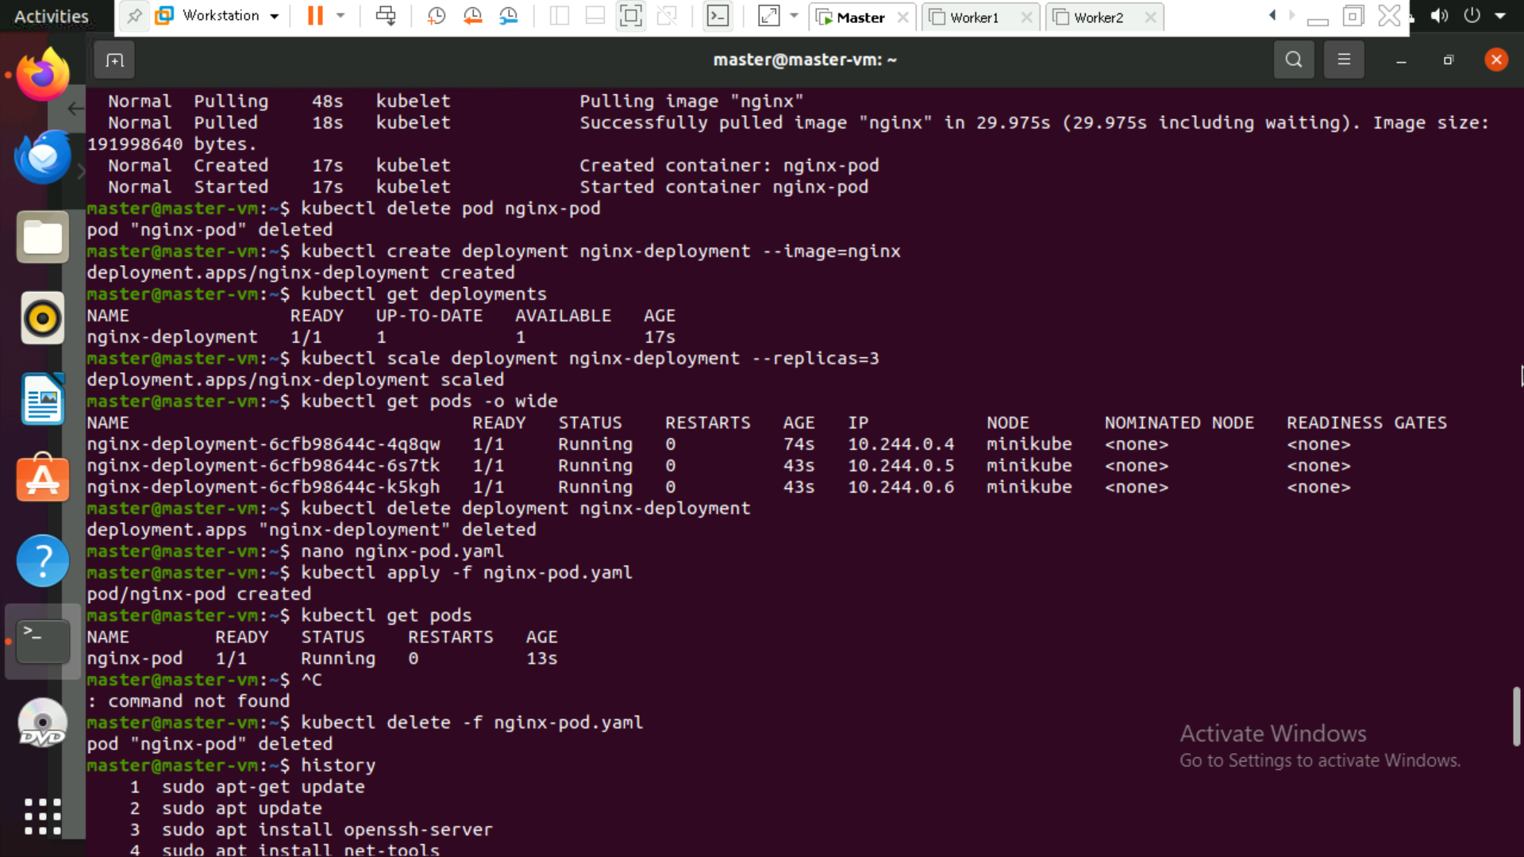

4)Create and Use a ConfigMap

